Building a Simple AI Agent with LangChain
A Step-by-Step Development Report
Prepared by: Amna Khurram
BS Data Science, University of Management and Technology (UMT), Lahore
GitHub: github.com/amnadev-ds
August 2026

1. Objective
The goal of this project was to design and build a simple, working AI agent using the LangChain framework in Python. An AI agent differs from a plain chatbot in one key way: instead of only generating text, it can reason about a task, decide which external tool to use, execute that tool, and then use the result to form a final answer. For this project, the agent was equipped with two tools: a calculator for arithmetic and a live web-search tool for real-world/current information. The project was completed end-to-end — from environment setup to a fully functional, tested agent — within a single-day timeframe.

2. Tools and Technologies Used
- Python — programming language used to write the agent
- Visual Studio Code (VS Code) — code editor used for development
- LangChain — Python framework used to build and orchestrate the AI agent
- Groq API — free, high-speed large language model (LLM) inference provider used as the "brain" of the agent
- DuckDuckGo Search (ddgs) — free search tool integrated into the agent, requiring no API key
- PowerShell Terminal (inside VS Code) — used to install packages and run the program

3. Step-by-Step Development Process

Step 1: Installing Visual Studio Code
The first step was installing VS Code, the code editor used throughout the project. During installation, the option "Add to PATH" was kept enabled — this allows VS Code and Python to be accessed directly from the terminal, which is essential for running scripts later.
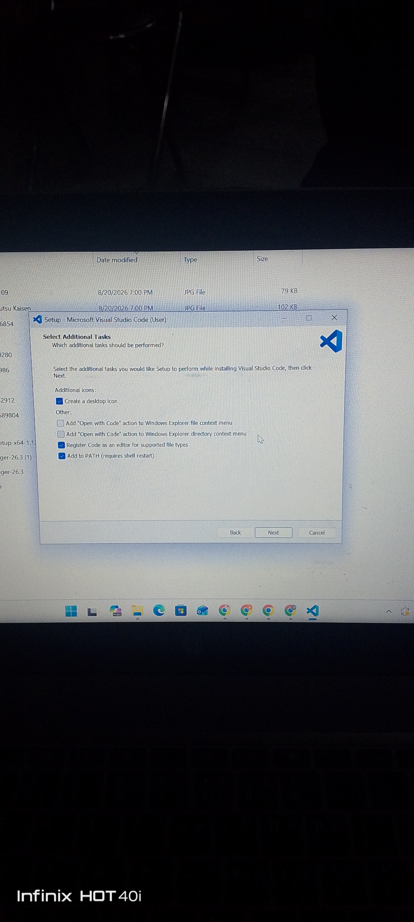
Figure 1: VS Code installation — Select Additional Tasks screen

Step 2: Setting Up the Project
After installation, VS Code was opened, a project folder named "agents vs" was created, and the folder was marked as "Trusted" to enable full editor functionality. A new Python file, simple_langchain_agent.py, was then created inside this folder.
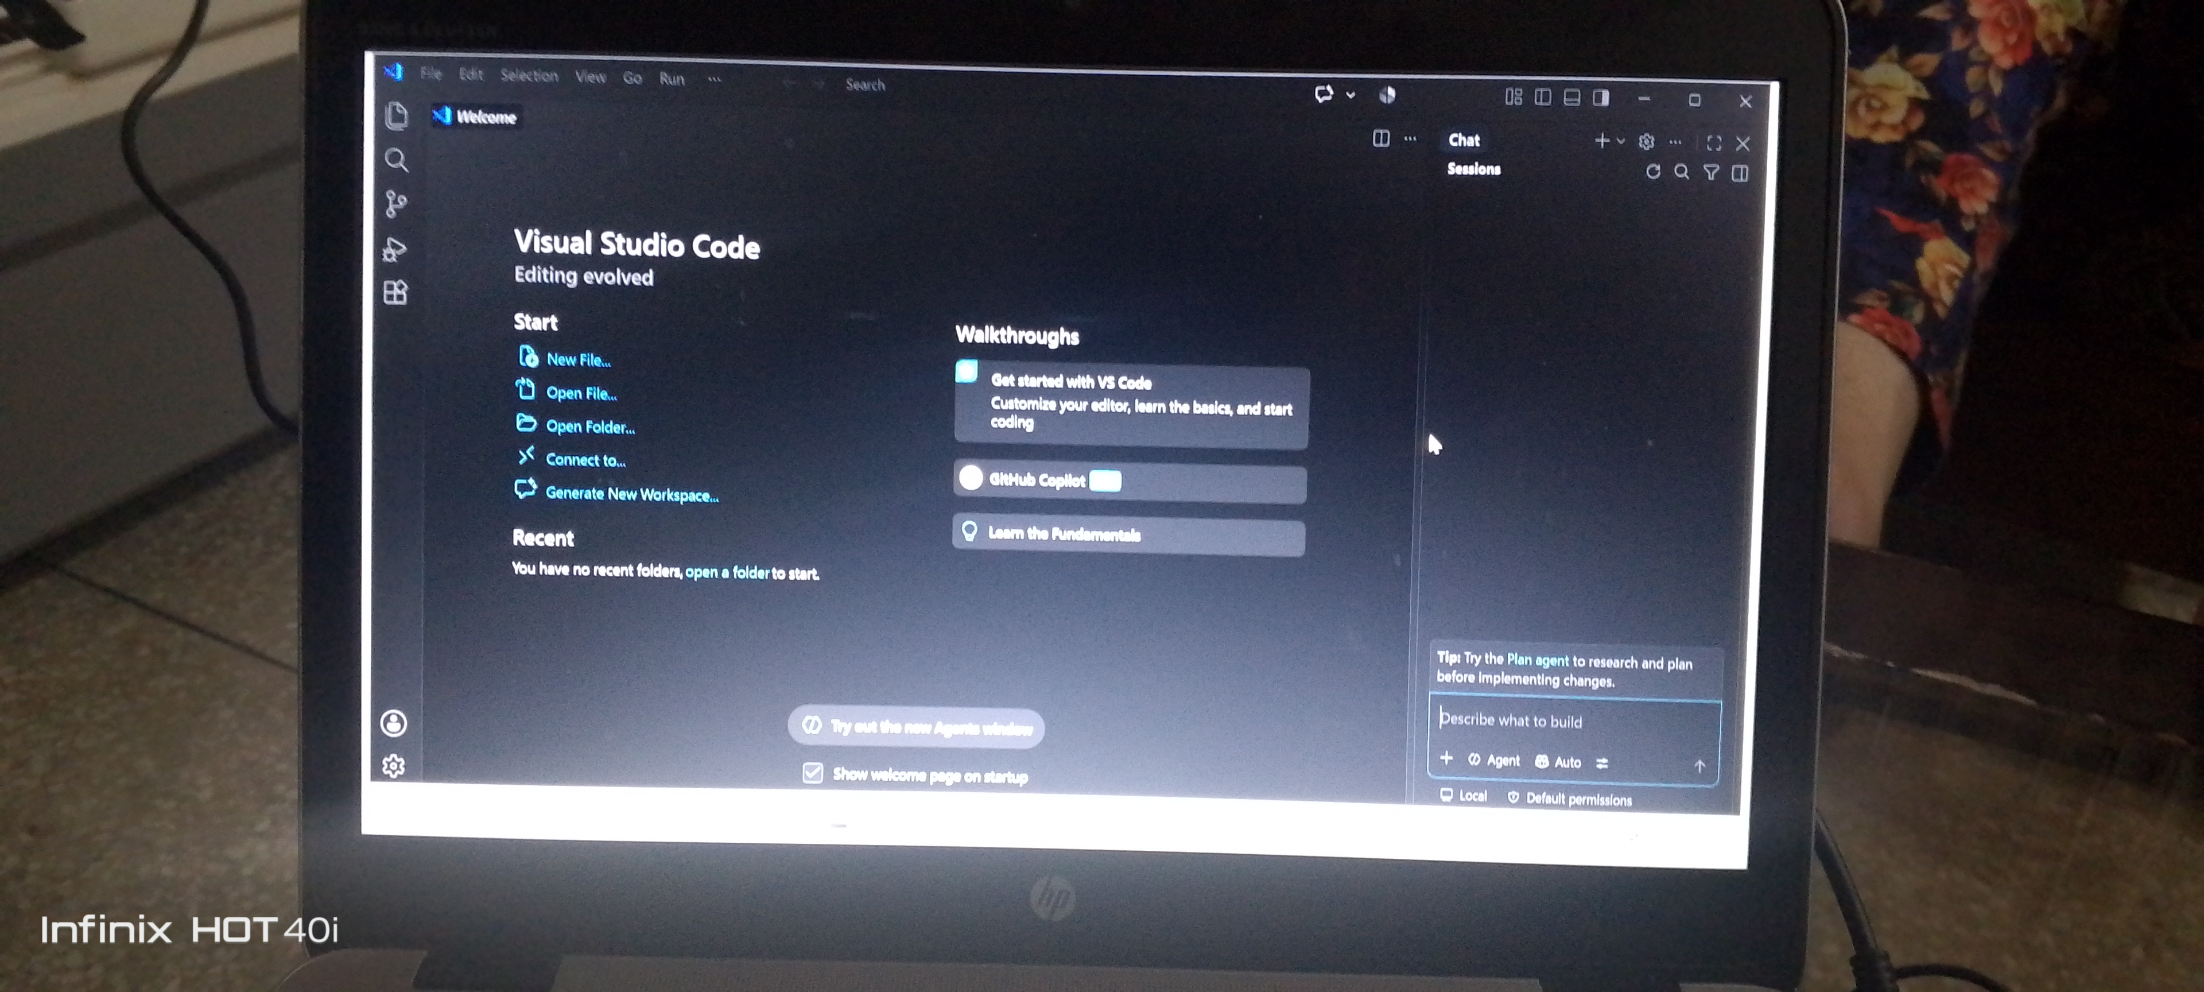
Figure 2: VS Code opened for the first time
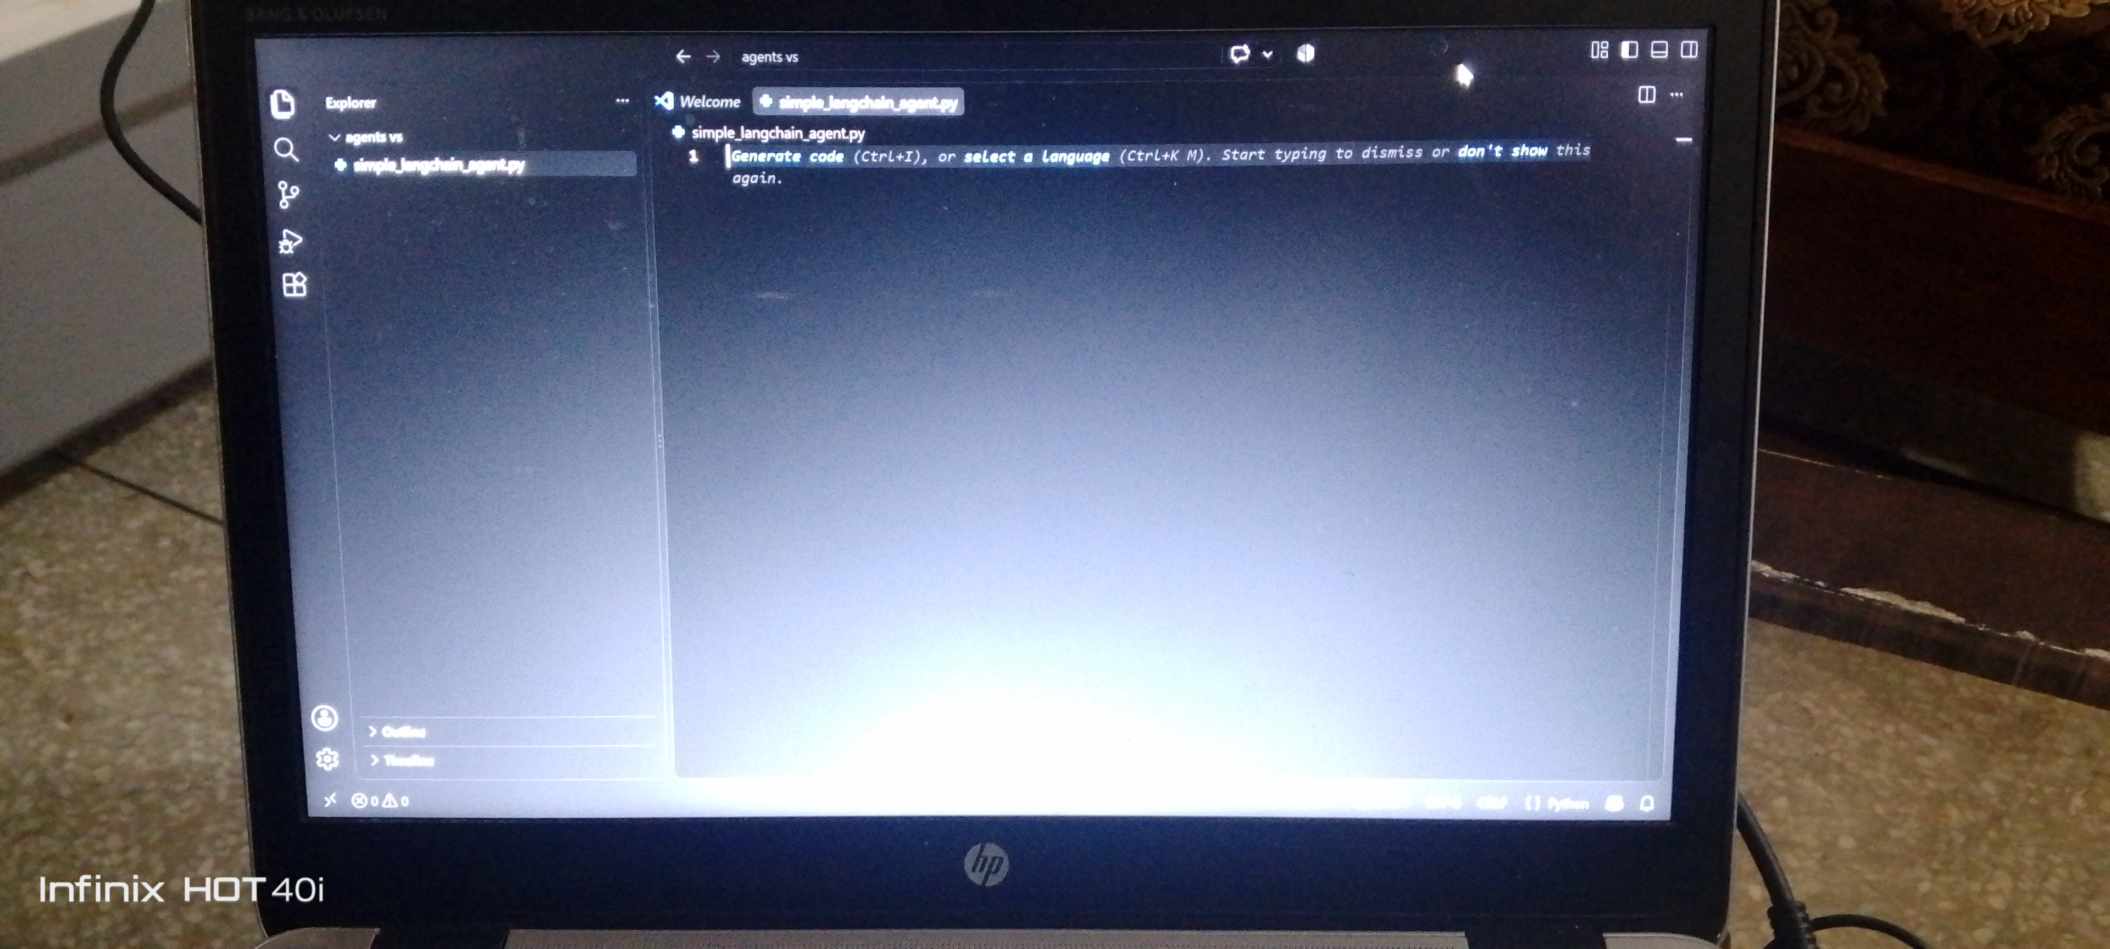
Figure 3: Project folder and simple_langchain_agent.py file created

Step 3: Installing Required Python Libraries
Using the integrated terminal in VS Code, the required Python packages were installed with pip, Python's package manager:
pip install langchain langchain-groq langchain-community ddgs
- langchain — the core framework used to build the agent
- langchain-groq — connects LangChain to the Groq LLM
- langchain-community — provides community-built tools, including the search tool
- ddgs — the DuckDuckGo search library used for the free web-search tool
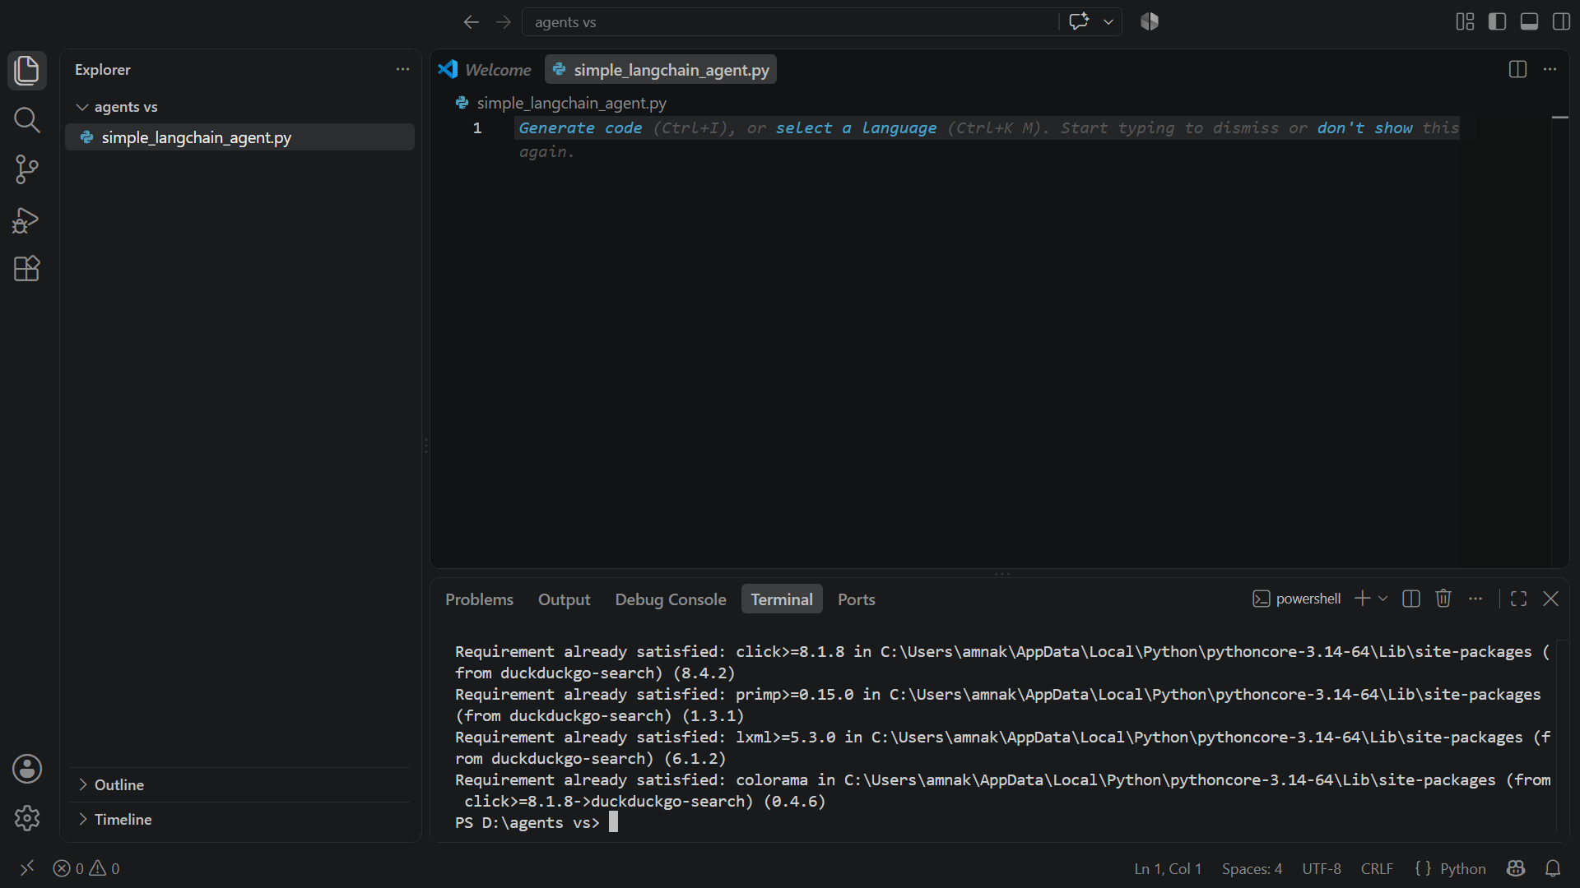
Figure 4: Terminal confirming successful package installation

Step 4: Writing the Agent Code
The complete Python script was written and saved inside simple_langchain_agent.py. A full explanation of the code is provided in Section 4 of this report.
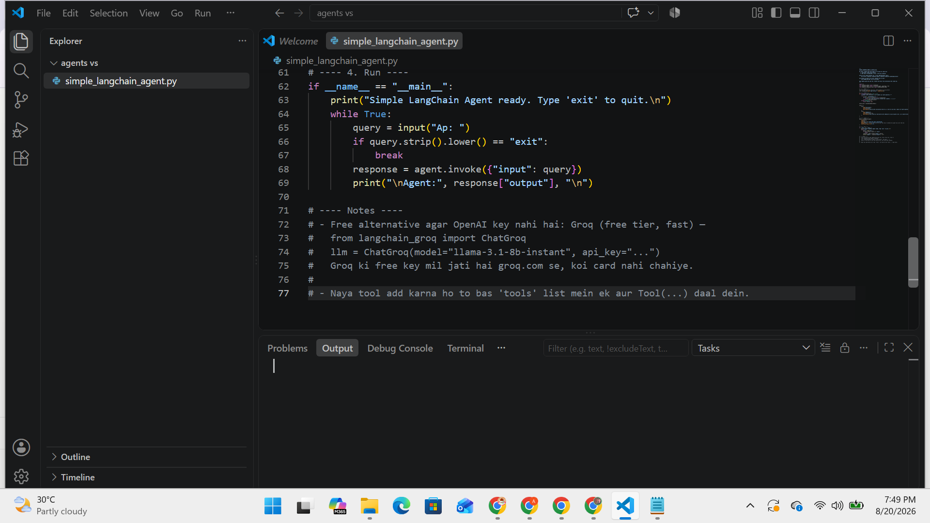
Figure 5: Completed agent code inside VS Code

Step 5: Creating a Free Groq API Key
Since the agent needs an LLM to "think," Groq was chosen as the model provider because it offers a genuinely free tier with very fast response times and does not require a credit card. The following steps were followed to obtain an API key:
- Visited console.groq.com and signed up using a Google account
- Opened the "API Keys" section from the top navigation menu
- Clicked "Create API Key," gave it a name (langchain-agent), and generated the key
- Copied the key immediately, since Groq only displays it once for security reasons
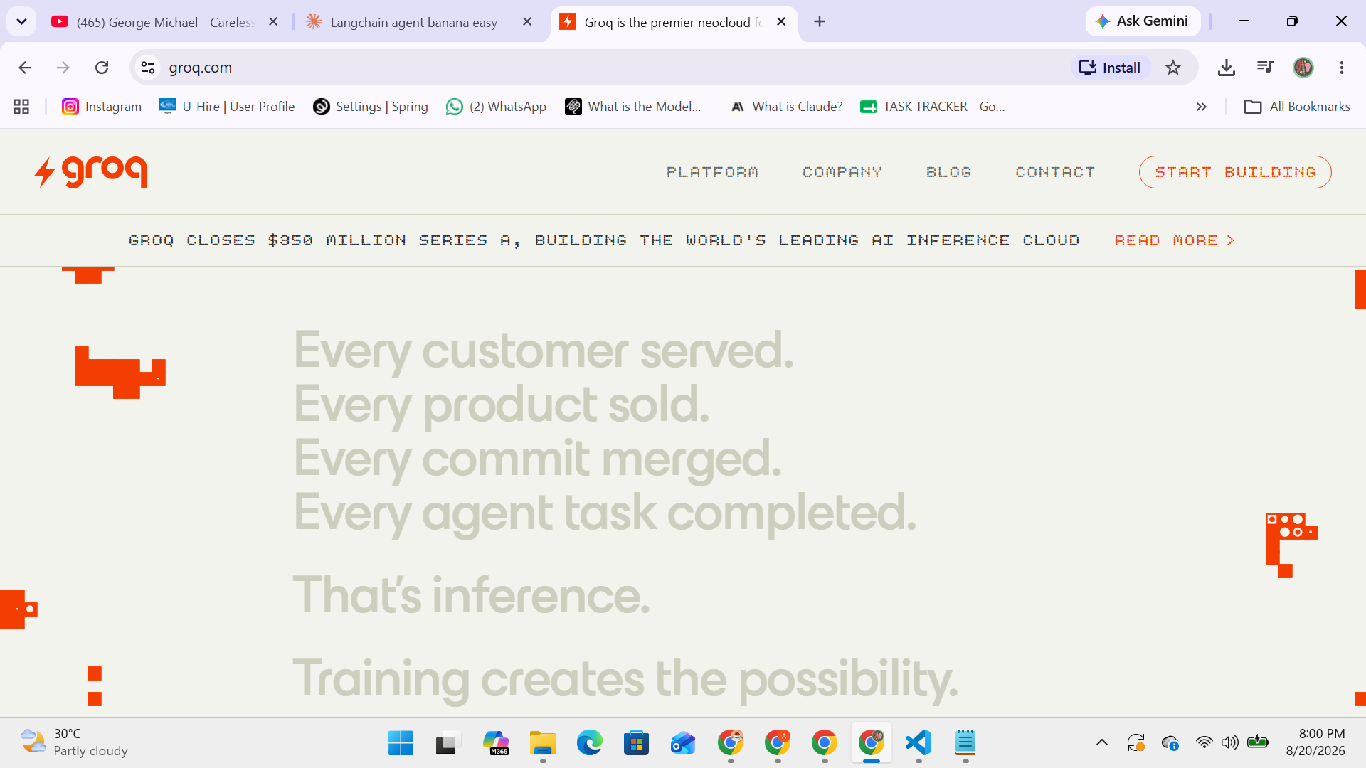
Figure 6: Groq Cloud homepage
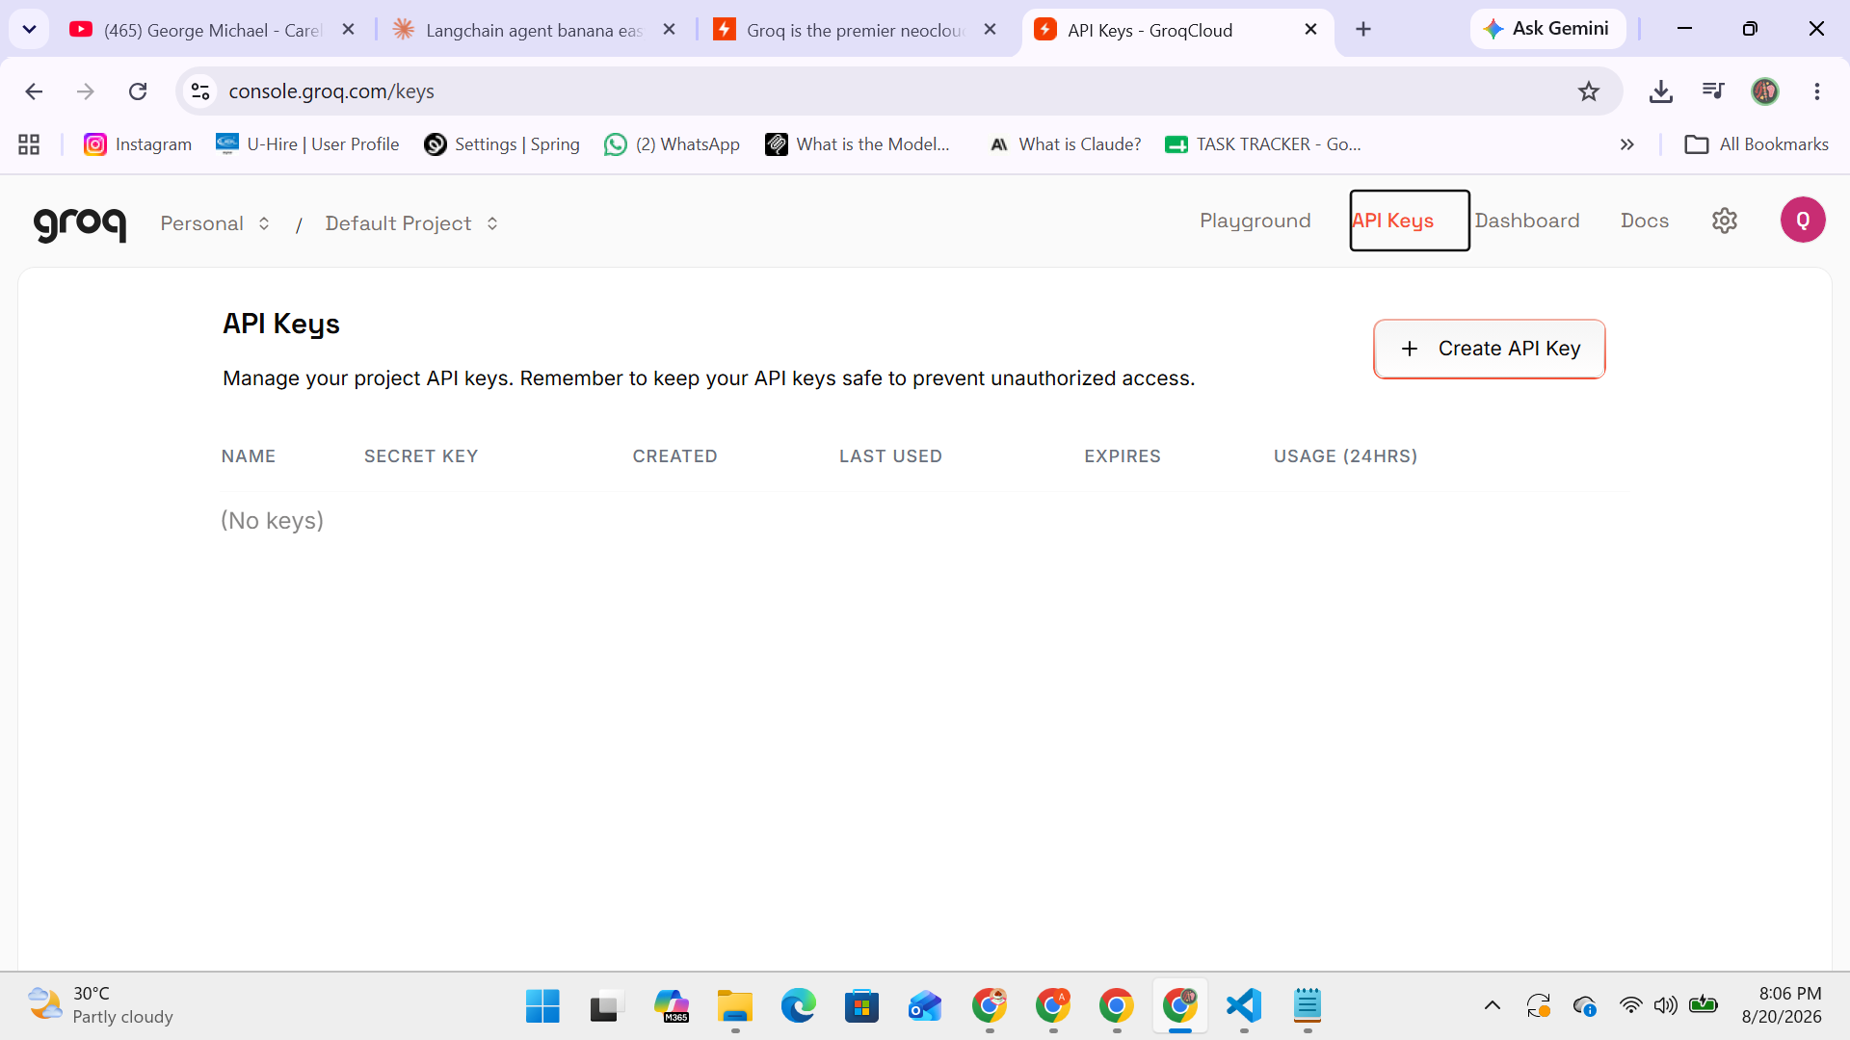
Figure 7: API Keys dashboard before key creation
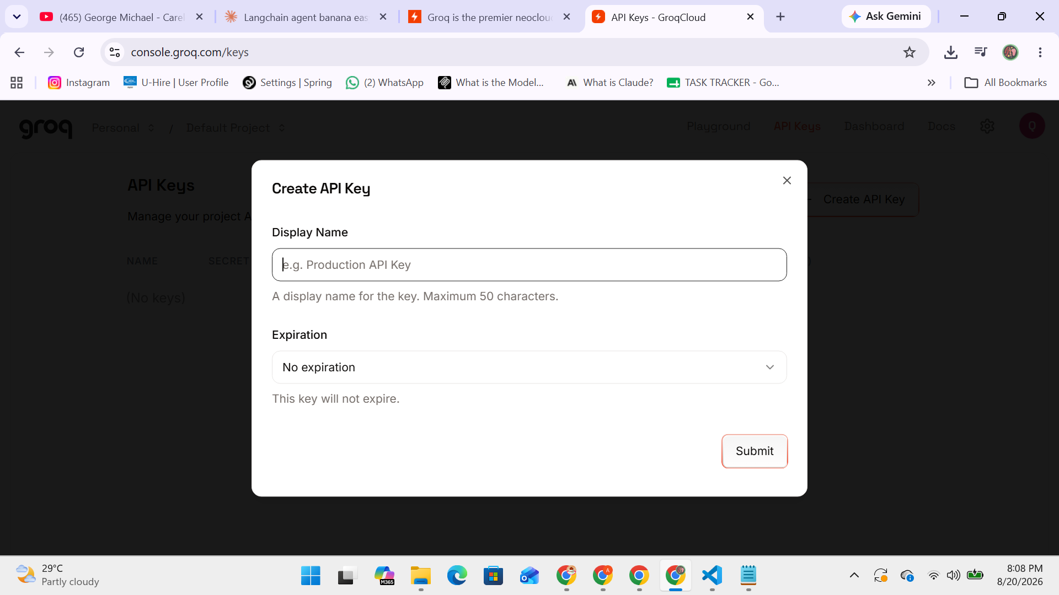
Figure 8: Create API Key dialog
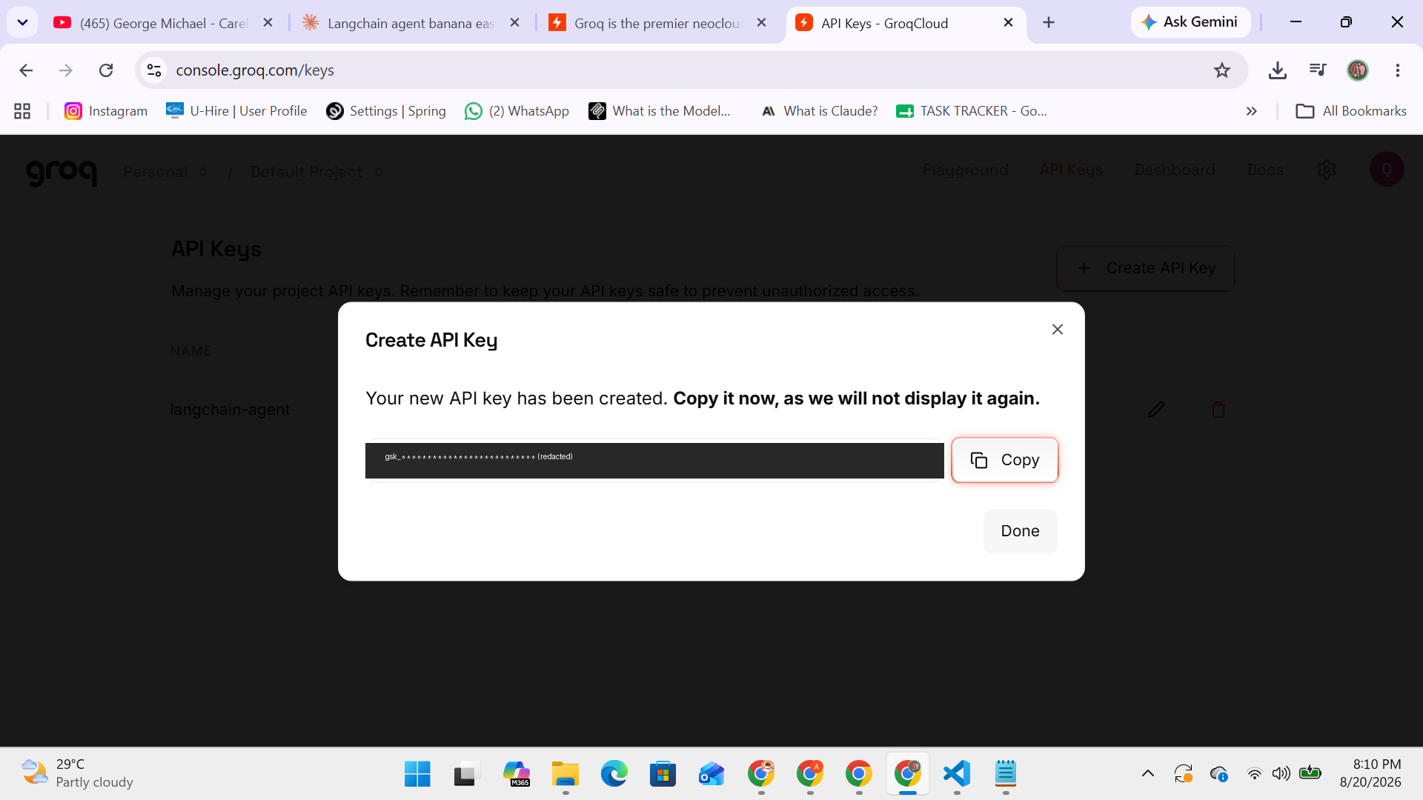
Figure 9: New API key generated (key value redacted for security)
Security note: API keys must always be treated as confidential, similar to a password. In this report, the key value has been intentionally blurred/redacted in every screenshot. As a best practice, the key used during development and testing was deleted from the Groq dashboard afterward and replaced with a new one that was never shared or displayed.

Step 6: Connecting the Agent to Groq
Once the API key was available, the model configuration line in the script was updated to authenticate with Groq and to specify which model to use:
llm = ChatGroq(
model="openai/gpt-oss-120b",
temperature=0,
groq_api_key="YOUR_API_KEY_HERE"
)
The model name was confirmed directly from the Groq Playground, since Groq periodically updates which models are actively supported.

Step 7: Debugging and Problem-Solving
Real-world development rarely works perfectly on the first attempt, and this project was no exception. Several errors were encountered and resolved during testing — a normal and valuable part of the development process. The table below summarizes the main issues faced and how each was diagnosed and fixed.
Error Encountered | Root Cause | Resolution
ImportError: cannot import name 'initialize_agent' | LangChain released a major version update (1.x) that replaced the older agent-creation API with a new one. | Replaced the deprecated initialize_agent() function with the current create_agent() function.
ImportError: Could not import ddgs package | The underlying search library was renamed from duckduckgo-search to ddgs by its maintainers. | Installed the correctly named package: pip install -U ddgs
groq.NotFoundError: model does not exist (404) | The originally chosen model name (llama-3.1-8b-instant) had been deprecated on Groq's platform. | Verified the current active model name directly from the Groq Playground and updated the code accordingly.
Windows Firewall prompt during execution | Python requested network access to reach the Groq API over the internet for the first time. | Allowed the connection, since it originated from the trusted, verified "Python Software Foundation" publisher.
Table 1: Summary of issues encountered during development and their resolutions
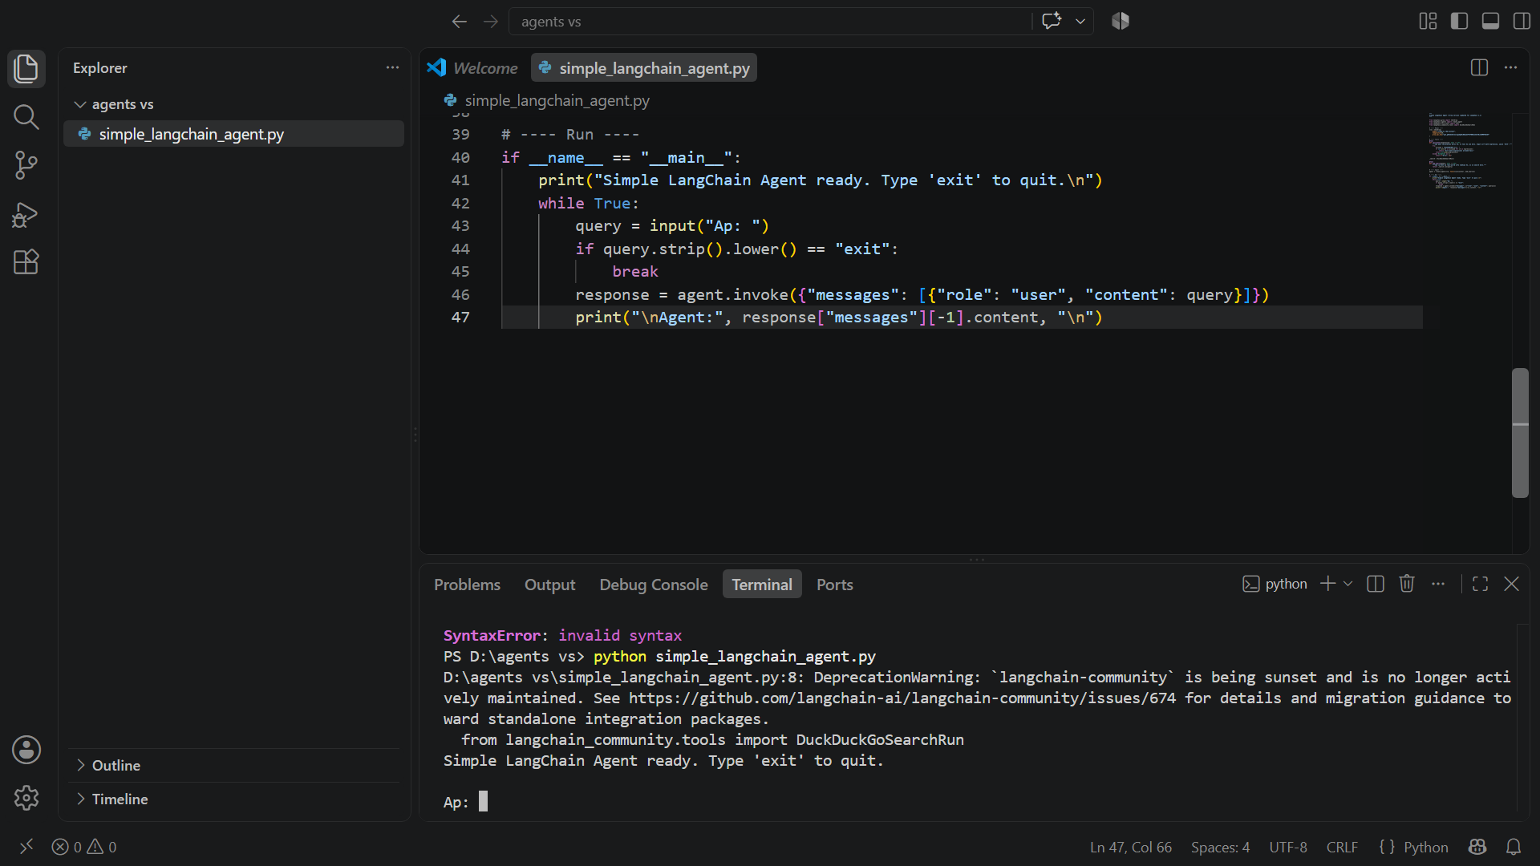
Figure 10: Agent successfully launched and awaiting user input
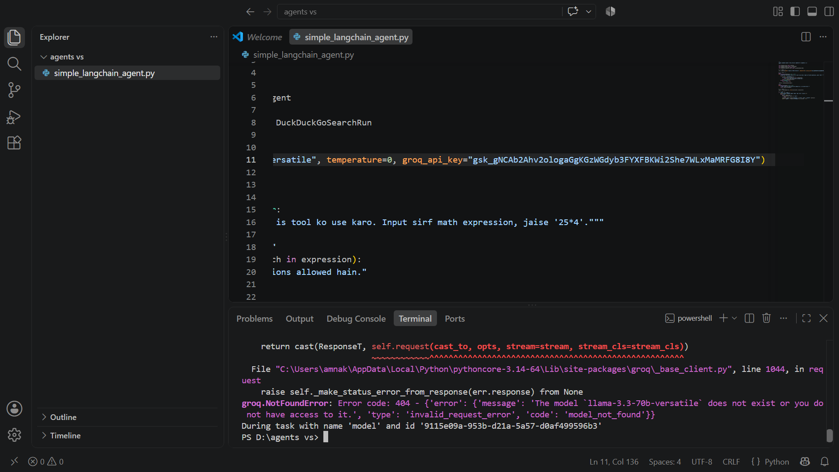
Figure 11: Example of a model-not-found error during debugging

Step 8: Final Testing
Once all issues were resolved, the agent was tested with two different types of queries to confirm that both integrated tools were functioning correctly.
Test 1 — Web Search Tool: The agent was asked about the current weather in Lahore. It correctly recognized that this required live, real-world information, invoked the search tool, and returned an accurate, well-sourced answer.
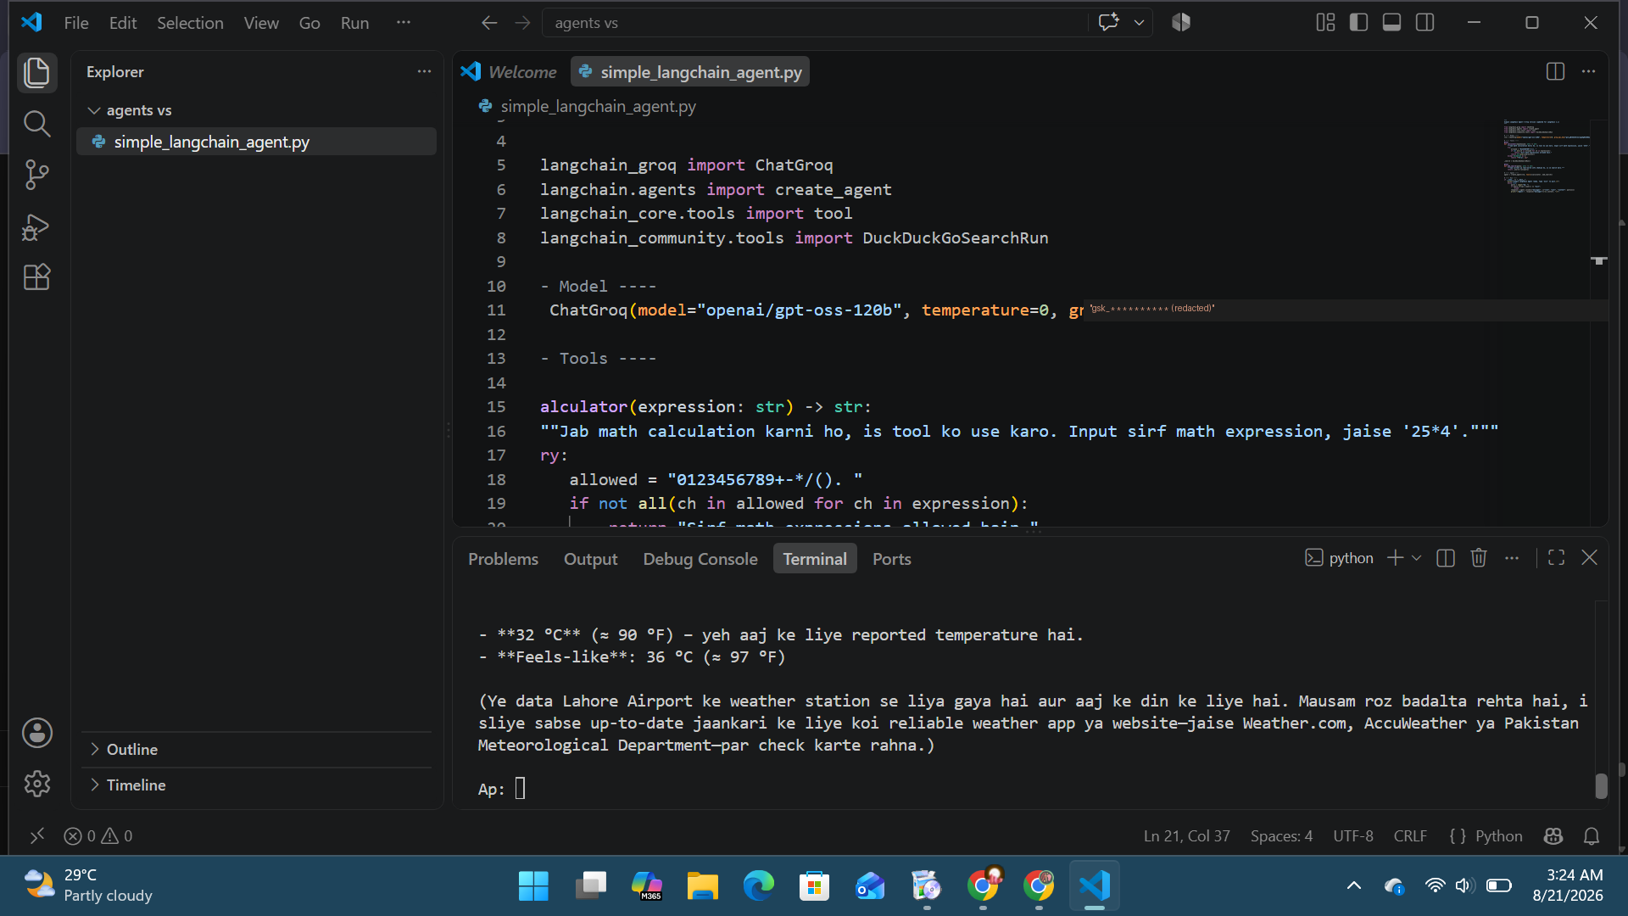
Figure 12: Agent correctly using the web-search tool for a live weather query
Test 2 — Calculator Tool: The agent was asked to solve "125 × 8." It correctly recognized this as a math operation, invoked the calculator tool instead of guessing, and returned the exact result (1000).
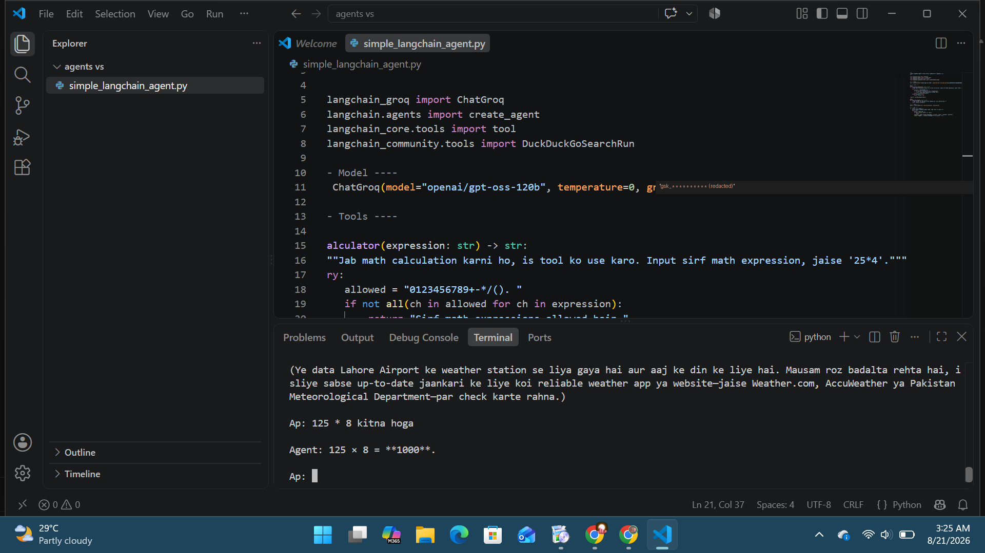
Figure 13: Agent correctly using the calculator tool for an arithmetic query

4. Detailed Code Explanation
The final version of the script is explained below, section by section.

4.1 Imports
from langchain_groq import ChatGroq
from langchain.agents import create_agent
from langchain_core.tools import tool
from langchain_community.tools import DuckDuckGoSearchRun
- ChatGroq — connects LangChain to Groq's hosted language model
- create_agent — the current LangChain function used to build a tool-using agent
- tool — a decorator used to turn an ordinary Python function into a tool the agent can call
- DuckDuckGoSearchRun — a ready-made, free web search tool

4.2 Configuring the Language Model
llm = ChatGroq(
model="openai/gpt-oss-120b",
temperature=0,
groq_api_key="YOUR_API_KEY_HERE"
)
The temperature parameter controls how random or deterministic the model's responses are. Setting it to 0 makes the agent's reasoning and tool choices as consistent and predictable as possible, which is important for reliable agent behaviour.

4.3 Defining the Calculator Tool
@tool
def calculator(expression: str) -> str:
"""Use this tool for math calculations."""
try:
allowed = "0123456789+-*/(). "
if not all(ch in allowed for ch in expression):
return "Only math expressions are allowed."
return str(eval(expression))
except Exception as e:
return f"Error: {e}"
The @tool decorator registers this function as something the agent can choose to call. The docstring (the text in triple quotes) is not just documentation — it is what the language model reads to decide when this tool should be used, so it must be written clearly. For safety, the function only allows digits and basic math symbols before evaluating the expression, preventing misuse of Python's eval() function.

4.4 Defining the Search Tool
_search = DuckDuckGoSearchRun()

@tool
def web_search(query: str) -> str:
"""Use this tool to look up current or real-world information."""
return _search.run(query)
This wraps the ready-made DuckDuckGo search utility as a second tool the agent can call whenever a question requires up-to-date or factual information that the language model would not otherwise know.

4.5 Creating the Agent
agent = create_agent(llm, tools=[calculator, web_search])
This single line combines the language model with both tools to produce a working agent. Internally, the agent follows a reasoning loop: it reads the user's question, decides whether a tool is needed, calls the appropriate tool if so, reads the tool's result, and then produces a final answer — repeating this process until it is confident in its response.

4.6 Running the Agent
if __name__ == "__main__":
print("Simple LangChain Agent ready. Type 'exit' to quit.\n")
while True:
query = input("You: ")
if query.strip().lower() == "exit":
break
response = agent.invoke({"messages": [{"role": "user", "content": query}]})
print("\nAgent:", response["messages"][-1].content, "\n")
- if __name__ == "__main__": ensures this code only runs when the file is executed directly, a standard Python convention
- A while loop keeps the conversation running until the user types "exit"
- agent.invoke() sends the user's message to the agent and runs its full reasoning/tool-use process
- The final line prints only the agent's last message, which is its answer to the user

5. Challenges and Learning Outcomes
The most valuable part of this project was not writing the initial code, which took only a short time, but resolving the real errors that appeared when the code was actually run. Because LangChain and its surrounding ecosystem update frequently, the exact function names, package names, and available models can change between when documentation or tutorials are written and when the code is actually run. This project involved reading error messages carefully, identifying the true root cause of each one, and applying the correct fix — a core, transferable skill in real-world software and AI development.
Key takeaways from this project include:
- Practical understanding of how AI agents differ from simple chatbots — through reasoning and tool selection
- Hands-on experience integrating a third-party LLM API (Groq) into a Python application
- Ability to read Python tracebacks and error messages, diagnose root causes, and apply targeted fixes
- Awareness of API key security best practices, including never exposing keys publicly and rotating them when needed
- Experience setting up a complete Python development environment from scratch using VS Code

6. Conclusion
This project successfully resulted in a fully functional AI agent capable of intelligently choosing between a calculator tool and a live web-search tool based on the nature of a user's question. Both tools were tested and confirmed to work correctly, and the complete development process — including the debugging challenges — has been documented in this report as evidence of practical, applied problem-solving with modern AI development tools.

